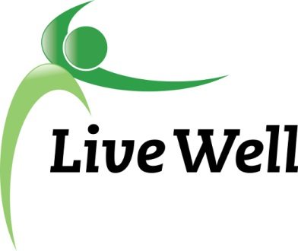
AGENDA

Healthy Food For All Work Group

Community Health Facility, First Floor Meeting Room, 200 Maine Street, Lawrence, Kansas 66044

9:00am – 10:00 a.m., Friday, December 11, 2015

Agenda items | Notes | Action Items
- Introductions and overview of agenda | We had a number of new faces join the group – a hearty welcome to our new members! | Come again! ;)
- Presentation and discussion by Helen Schnoes on Food Systems Assessment research proposal for the Douglas County Food Policy Council. | Barb LaClair (formerly of Kansas Health Institute) has been hired by the Douglas County Food Policy Council and LiveWell to create a report on the local food environment, including a focus on healthy equity and food access issues. This report will be used to inform action planning for revisions to Horizon 2020 (comprehensive plan). The assessment will include data on the food retail environment and food deserts, food insecurity rates, SNAP enrollment and SNAP eligibility, WIC, numbers of students qualifying for free or reduced lunch, Map the Meal Gap data, fruit and vegetable consumption, etc., along with qualitative data from community meetings and focus groups. Also discussed working with Sunrise Project youth (possible PhotoVoice project?)Discussed ways to partner with food pantires to capture community members’ stories, possibly through a paper plate campaign where clients can write on a paper plate a sentence or two about their story or what the food pantry support means to them; this can also be powerful to share with policymakers. Will be important to intentionally gbuild in inclusive feedback opportunities. This data will also be used to inform the community health assessment and community health improvement plan led by the Health Department and other partners. A graphic designed will help distill key data in infographic communications. | Elizabeth Keever will send Just Food’s planned annual survey for the group’s review (to be distributed to Just Food Clients in January).  Helen Schnoes (Food Systems Coordinator for Douglas County) will attend future HFFA Work Group meetings.
- Updates of current projects (SNAP Outreach, Market Match, Other updates) | Focus group held 11/19/15 to get feedback from participants on the Market Match program. Participants reported high levels of satisfaction with the MM Program and spent time brainstorming how to get the word out better about the program among those who could benefit. Also discussed how to improve signage at the farmers’ markets to help people know where to go, and to promote the program.  Market Match dollars will be tripled at the Holiday Market this Saturday.  A lot of progress is being made in SNAP outreach. Heartland Community Health Center now has staff assisting patients with SNAP applications. All AmeriCorps members will soon be trained on assisting with SNAP applications (this will include workers at Community Shelter and United Way). Goal is that each day there will be people available to assist with SNAP applications.  SNAP – will track number of people trained to assist with applications, number of SNAP applications, number of people enrolled.  Quentin Cole, North Lawrence resident, reported on efforts to improve food access, community engagement, build upon local trade economy. Plan is in 2016 to hold a farmstand at the Locust Street location twice a week, with a food truck on site one time per week. They are looking for a fiscal sponsor. Meeting with Sunrise this week to explore possibilities.  City has hired consultants to conduct a cultural arts plan, which will also include some aspects of food/ culture. | Shelley Mann will create a map of access points for SNAP enrollment assistance.  Additional training to those providing SNAP enrollment assistance.  Quentin Cole and Sunrise Project staff meeting to explore partnership.
- Summary of highlights and action items to report to LiveWell Executive Committee.

- Adjournment | See you in the New Year!

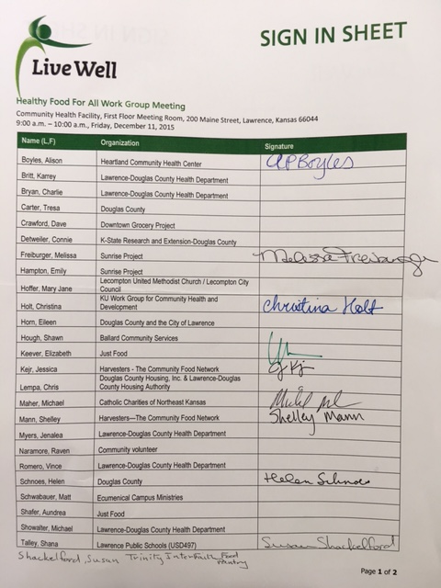
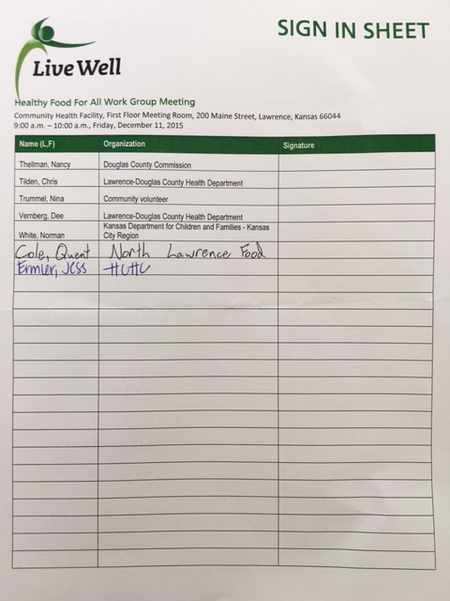
2015-2016 LiveWell Lawrence Committee Leadership (7/14/2015)

Committee | Chair | Chair-elect | Past chair | Communications Coordinator
Executive Committee | Eileen Horn | Laurie Comstock | Nikki White | --NA--
Healthy Built Environment | Tim Herndon | Marilyn Hull | Eric Struckhoff | Dot Nary
Healthy Food For All | Elizabeth Keever | TBD (work group meets on 7/31/15) | Raven Naramore | Nina Trummel
Healthy Kids | Shannon Jones | Brian Edie | Vanessa Sanburn | Mary Orem
Tobacco-Free Living | Janelle Martin and Erica Anderson | Yvonnes Chen | --NA-- | TBD
WorkWell Lawrence | Megan Stuke | Angie Sommer | Laurie Comstock | TBD

LiveWell Roadmap to a Healthier Douglas County: 2013-2018 Douglas County Community Health Plan
Strategy assigned to Healthy Food For All Work Group | Opportunities for Community Action (2015 revisions) | Outcomes / Objectives | Measures / Indicators related to strategy
Enhance access to healthy food for low-income families | - Establish waste minimizing practices and policies with supermarkets, restaurants, cafeterias, schools, hospitals and any other large feeding institutions, restaurants and stores by supplying excess to food banks serving Douglas County (for low-income families)  - Promote and advocate for changes in local food bank and pantry policies and practices that improve the nutrition and health status of communities, including:  - Implementing choice-based systems  - Providing incentives for selecting healthy whole local foods  - Providing evidence-based case management  - Promoting SNAP enrollment  - Increasing capacity for storing and distributing healthy whole foods  - Establishing new locations  - Improving transit access to existing locations  - Establish a system that engages low-income families as food growers  - Establish a system that engages low-income families as small food business operators  - Establish new opportunities to purchase fresh produce in North Lawrence and other parts of Douglas County with limited options, including farmer’s markets, integration into existing retail options, or opening corner stores  - Promote and advocate for increased enrollment in Supplemental Nutrition Assistance Program (SNAP) through efforts including dollar for dollar matching programs, community-wide campaigns that destigmatize food assistance and improve understanding of the benefits of SNAP participation | - By 2018, increase by 10% the availability of fruits and vegetables in food deserts through retail, gardens, and food banks.  - By 2018, increase by 5% participation in SNAP/ food stamps. | - Number of opportunities to purchase or obtain fruits and vegetables (Environmental Observation)  - Number of people participating in SNAP/ food stamps (USDA Food and Nutrition Resources)

LiveWell Healthy Food For All Work Group Contacts (Updated July 29, 2015)
Name (L,F) | Work Group Role | Email | Phone | Organization | Position
Anderson, Erica | Support | eanderson@ldchealth.org | (785) 856-7347 | Lawrence-Douglas County Health Department | Health Promotion Specialist
Britt, Karrey | Support | kbritt@ldchealth.org | (785) 856-7362 | Lawrence-Douglas County Health Department | Communications Coordinator
Bryan, Charlie | Support | cbryan@ldchealth.org | (785) 856-7357 | Lawrence-Douglas County Health Department | Community Health Planner
Carter, Tresa | Member | tcarter@douglas-county.com | (913) 710-2669 | Douglas County | Sustainability Programs Manager
Crawford, Dave | Member | dcraw4d@hotmail.com | (785) 218-4279 | Downtown Grocery Project | Lead Organizer
Detweiler, Connie | Member | cdetweil@ksu.edu | (785) 843-7058 | K-State Research and Extension-Douglas County | Family Nutrition Program/SNAP-ED Member
Garza, Rebecca | Support | rgarza@ldchealth.org | (785) 856-5430 | Lawrence-Douglas County Health Department | Health Promotion Specialist
Hoffer, Mary Jane | Member | mjhoffer9@gmail.com | (785) 393-3382 | Lecompton United Methodist Church / Lecompton City Council | Food pantry volunteer / Council Member
Holt, Christina | Member | cholt@ku.edu | (785) 864-0533 | KU Work Group for Community Health and Development | Associate Director for Community Tool Box Services
Horn, Eileen | Member | ehorn@douglas-county.com | (785) 330-3121 | Douglas County and the City of Lawrence | Sustainability Coordinator
Keever, Elizabeth | Chair | ekeever@justfoodks.org | (214) 532-8355 | Just Food | Chief Resource Officer
Kejr, Jessica | Member | jkejr@harvesters.org | (785) 861-7704 | Harvesters - The Community Food Network | Agency Services Manager
Lopes, Steve | Member | slopes1@aol.com | (785) 842-7137 | Community volunteer
Mann, Shelley | Member | smann@harvesters.org | (816) 929-3280 | Harvesters—The Community Food Network | SNAP Outreach Coordinator
Naramore, Raven | Past Chair | raven_n@hotmail.com | (785) 766-2240 | Community volunteer
Romero, Vince | Support | vromero@ldchealth.org | (785) 856-5365 | Lawrence-Douglas County Health Department | Analyst
Schnoes, Helen | Member | hschnoes@douglas-county.com | (785) 832-5157 | Douglas County | Food Systems Coordinator
Schwabauer, Matt | Member | schwabauer@gmail.com | (785) 393-7301 | Ecumenical Campus Ministries | Board Member
Shafer, Aundrea | Member | ashafer@justfoodks.org | (785) 856-7030 ext. 7014 | Just Food | Programs
Talley, Shana | Member | stalley@usd497.org | (785) 312-4544 | Lawrence Public Schools (USD497) | Parent Facilitator for New York Elementary & Schwegler Elementary
Thellman, Nancy | Member | nthellman@douglas-county.com | (785) 550-7754 | Douglas County Commission | Commissioner
Tilden, Chris | Support | ctilden@ldchealth.org | (785) 843-3060 | Lawrence-Douglas County Health Department | Community Health Director
Trummel, Nina | Communications Coordinator | ninalimonchi@gmail.com | (951) 609-6589 | Community volunteer
Vernberg, Dee | Support | dvernberg@ldchealth.org | (785) 843-3060 | Lawrence-Douglas County Health Department | Analyst
White, Norman | Member | norman.white@dcf.ks.gov | (785) 832-3707 | Kansas Department for Children and Families - Kansas City Region | Client Affairs/Community Relations

Please complete one entry for each activity (e.g., instance of training; service delivery). Be sure to describe clearly and completely so that others outside your organization can know what happened.

Name: Email Address: Date:

WHO led the activity/event? |  | WHERE did the activity/event take place?
WHAT occurred?
WHEN? (date of activity) | With WHOM? (partners, other orgs) |  | HOW MANY people in the community were involved/affected?
Toward what GOAL?

WHO led the activity/event? |  | WHERE did the activity/event take place?
WHAT occurred?
WHEN? (date of activity) | With WHOM? (partners, other orgs) |  | HOW MANY people in the community were involved/affected?
Toward what GOAL?

WHO led the activity/event? |  | WHERE did the activity/event take place?
WHAT occurred?
WHEN? (date of activity) | With WHOM? (partners, other orgs) |  | HOW MANY people in the community were involved/affected?
Toward what GOAL?

